**Computer Science – UX/UI Design & Usability**

**Semester 1**

**BSC109224 Group A**

**Assignment 1**

**Student: Lucas Madeira Maranho**

**Student ID: 76990**

**Lecturer: Seamus Hickey**

Summary

1. What is Capoeira? 3

2. Instruments: 3

3. Why those colours in the poster and Logo? 5

4. References 6

CAPOEIRA

1. What is Capoeira?

Capoeira is a Brazilian martial art which is a mix of dance, acrobatics, music and self-defence. It came from the 16th century when Africans brought to Brazil used it as culture and resistance against oppression.

Capoeira developed in areas of Brazil, the most in the northeastern county. Enslaved People would practice those movements as a dance to avoid punishment and to maintain their culture identity.

Capoeira became a wrong thing to practice after the abolition in 1888, it was treated as a criminal thing and was banned or several decades.

After years some important people like Mestre Bimba and Mestre Pastinha helped to bring capoeira back as a cultural practice.

1. Instruments:

There are some essential instruments that are part of capoeira and have a unique rhythm. They are:

* Berimbau – This instrument used to be made of wooden or bamboo bow with a stretched string, usually made of a plant Fiber or animal tendon, but now, instead of a stretched string, it is a steel wire and there is a gourd.

It is between 1.20 and 1.40 meters.

* Atabaque – This instrument, the body is made of wood and covered with goat or calf skin. It can be made in a cylindrical shape, usually compromise between a conical and barrel shape and sometimes, it can have an hourglass-shaped base. Berimbau and Atabaque are who give the rhythm to the dance.

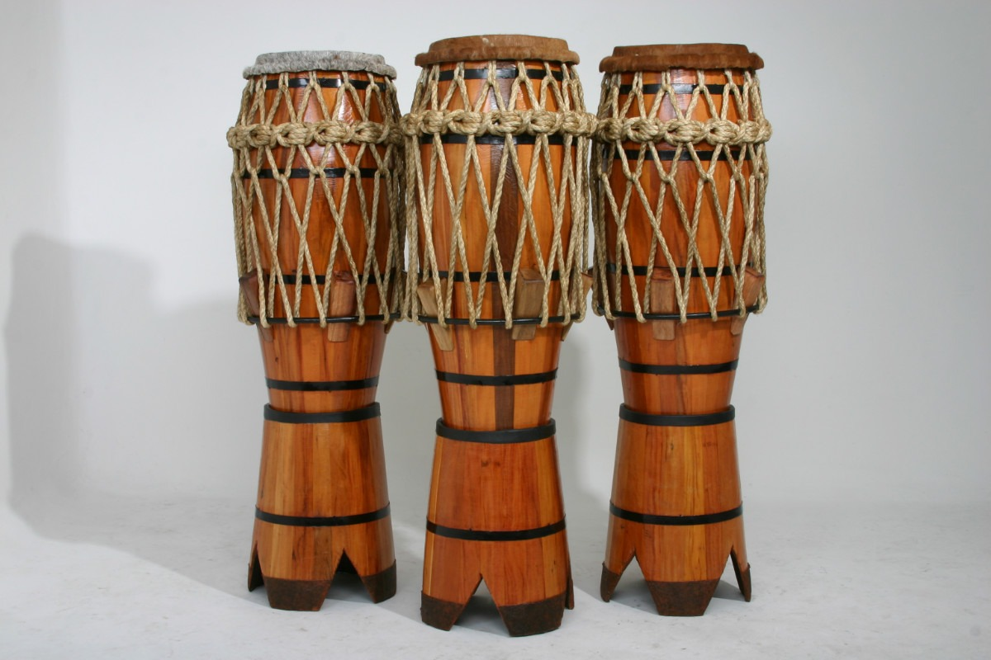

* Pandeiro – This instrument is a circular wooden hoop with floors, on which goat skin is stretched. Pandeiro is used alongside the caxixi and the chant and has a higher pitched sound than the atabaque.

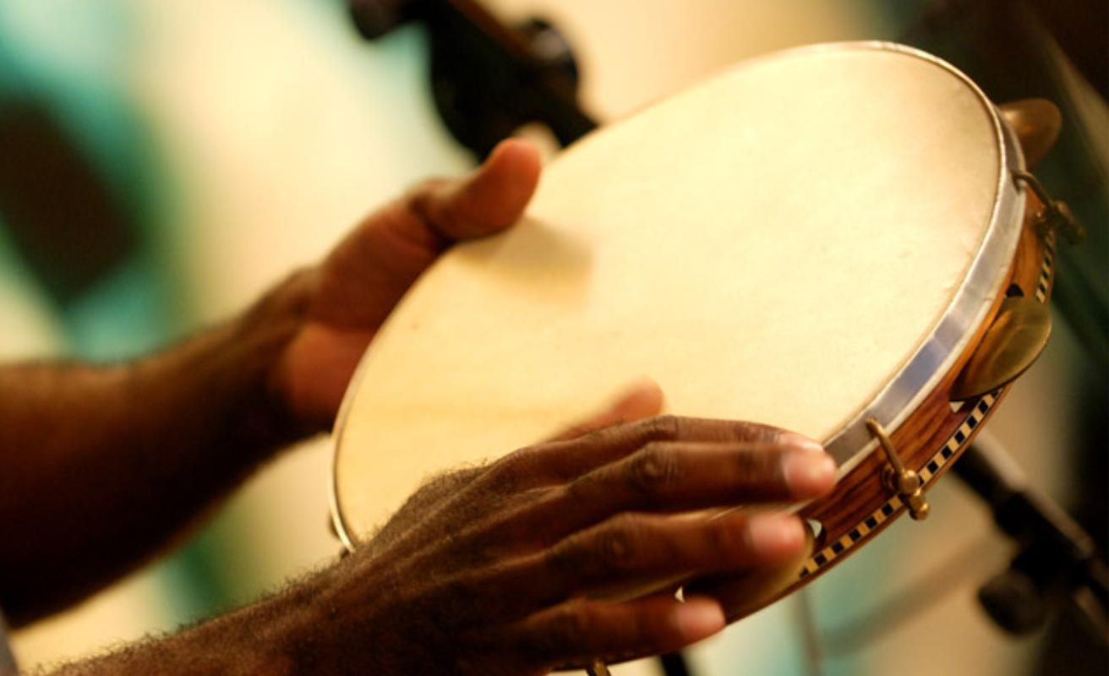

* Agogo – this instrument is made up of a small bow and a metal handle that ends in two metal cones of different sizes, which produce two different sounds when played with an iron stick, it can be made of wood as well. It is combined with the sounds of the berimbau and atabaque, it serves as a rhythmic counterpoint to both.

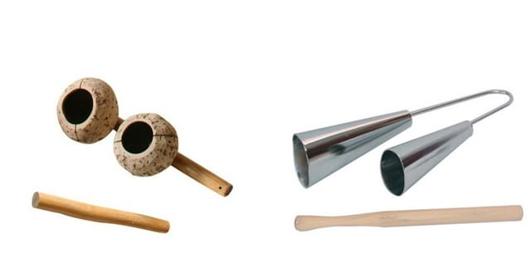

1. Why those colours in the poster and Logo?

As capoeira was created in Brazil long time ago, choosing colours was easy. One of the most important things for a country is the flag, which is why the choice was made based on Brazilian flag.

The poster colour was chosen based on the picture in the centre, so, to combine the colours and show the lightness that capoeira means, the colour blue was chosen.

1. References

<https://www.bahiaexperience.com.br/salvador-tours/half-day-berimbau-percussion-class/>

<https://capoeira.alsace/la-capoeira/les-instruments/>

<https://www.sabra.org.br/site/capoeira-instrumentos/#:~:text=Pandeiro,m%C3%BAsica%20com%20as%20chamadas%20viradas>.

<https://www.reddit.com/r/capoeira/comments/12vxg66/what_agogo_is_better_wood_or_metal/?rdt=46667>